Clinical Data Registry Reporting for Eligible Professionals
New Hampshire Providers

Public Health Objective Documentation Aid
Program Year 2019, MU Stage 3: Objective 8 Option 5A and OptioB

- For the purpose of Stage 3 Meaningful Use, Clinical Data Registries are “administered by, or on behalf of, non-public health agency entities.”
- The New Hampshire Department of Health and Human Services registries are not counted as Clinical Data Registries.
- Clinical Data Registries may be sponsored or maintained by national or medical societies, patient safety organizations, or quality improvement organizations.
- An Eligible Professional (EP) may report to more than one Clinical Data Registry, and may count Clinical Data Registry reporting more than once to meet the Public Health Objective. MAPIR has two screens for Clinical Data Registry reporting:
  - Objective 8 Option 5A, and
  - Objective 8 Option 5B.
- If an EP takes an exclusion and answers ‘No’ to Option 5A, no data entry will be allowed for Option 5B.
- If a NH EP attests to Active Engagement for Option 5A, they may be required to select Option 5B and attest to Active Engagement with an additional Clinical Data Registry, or exclude from an additional Clinical Data Registry reporting period requirement.
  - NH EPs are not required to select Option 5B if they attested to Active Engagement with the NH Cancer Registry for the Public Health Registry (Option 4) and Active Engagement for Option 5A.
- A provider may be a member of more than one organization that has a Clinical Data Registry. It is the provider’s responsibility to check with any national societies or medical organizations with which they are affiliated to determine if those entities endorse or sponsor a registry. This must be assessed no later than the first day of the provider’s EHR reporting period.
- If an EP achieved Active Engagement Production status in PY2018 by sending non-HL7 file format data, they can continue sending this file format in 2019, as long as the file was generated by their 2015 Edition CEHRT.
- If an EP did not achieve Active Engagement Production status in 2018, then all engagement options (Registration, Testing/Validation, and Production) must be for HL7 file format generated from their 2015 Edition CEHRT.

Please Note: The terms “EHR Reporting Period,” “MU Reporting Period”, and “Promoting Interoperability (PI) Reporting Period” all refer to the continuous 90-day period within the Program Year in which an Eligible Professional demonstrates Meaningful Use of certified EHR technology.

Instructions:

- This form may be used for multiple attesting EPs, if the supporting documenation applies to more than one provider at a practice location. Please Note: EPs within the same practice may belong to different organizations, and therefore it is important to assess each provider’s affiliations individually.
- List the provider names, NPIs and the 2019 EHR/MU Reporting Periods on Page 3.
- Indicate on Page 3 whether or not the providers:
  - Are in Active Engagement with a Clinical Data Registry, or
  - Qualified for an Exclusion.
- Describe the Active Engagement supporting documentation for 2019 EHR/MU Reporting Period on Page 3.
- Utilize Page 7 for supporting documentation statements from providers taking an exclusion. All exclusions require a provider’s signature.

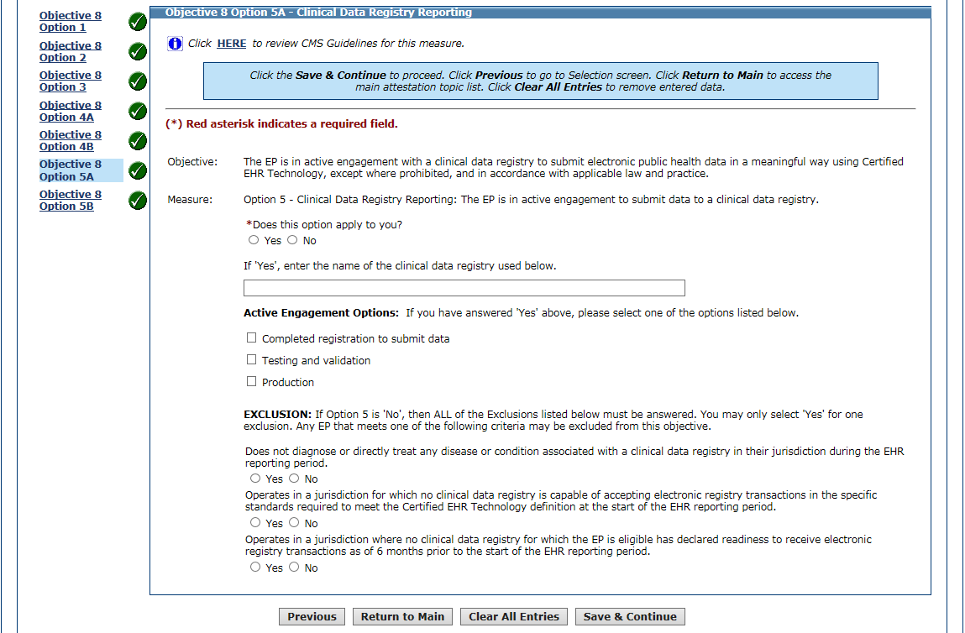
Screenshot from MAPIR: Objective 8 Option 5A – Clinical Data Registry Reporting

Eligible Professional  Name(s) | NPI | 2019 EHR/MU Reporting Period Dates | 5A: Clinical Data Registry  Active Engagement or Exclusion?
Use Page 7 to list more providers, if needed.

Attesting to Active Engagement for Option 5A

5A Active Engagement Option | Description of Supporting Documentation
1. Completed registration to submit data | (Examples: Registration form, communications from registry acknowledging registration or confirming good standing for PY2019 EHR/MU Reporting Period.)
2. Testing and validation | (Examples: Dated letter, email or screenshot from the registry acknowledging testing. If Test Date is before 2019, include description of ongoing testing during 2019 EHR/MU Reporting Period.)
3. Production | (Examples: Dated record of the transmission/transaction log, letter or email from the registry acknowledging submission of production data during 2019 EHR/MU Reporting Period.)
Upload the documentation to the provider attestation(s) in MAPIR or email it to ahs.dvhaEHRIP@vermont.gov

Taking an Exclusion for Option 5A

5A Exclusion Option | 5A Description of Suggested Supporting Documentation
1. Does not diagnose or directly treat any disease or condition associated with a clinical data registry in their jurisdiction during the EHR reporting period. | Sample supporting documentation statements (use page 7 to submit):  “I do not belong to any medical/specialty societies.”  Include signature and EHR/MU Reporting Period.
2. Operates in a jurisdiction for which no clinical data registry is capable of accepting electronic registry transactions in the specific standards required to meet the Certified EHR Technology definition at the start of the EHR reporting period. | Sample supporting documentation statements (use page 7 to submit):  “The medical/specialty society or societies I belong to was/were not capable of accepting data at the start of my EHR reporting period.”  List medical and specialty society memberships as of the beginning of the EHR/MU Reporting Period, include signature and EHR/MU Reporting Period.
3. Operates in a jurisdiction where no clinical data registry for which the EP is eligible has declared readiness to receive electronic registry transactions as of six months prior to the start of the EHR reporting period. | Sample supporting documentation statements (use page 7 to submit):  “The medical/specialty society or societies I belong to has/have not declared readiness to receive electronic registry transactions as of six months prior to the start of my EHR reporting period.”  List medical and specialty Society memberships as of the beginning of the EHR/MU Reporting Period, include signature and EHR/MU Reporting Period.
Upload the documentation to the provider attestation(s) in MAPIR or email it to ahs.dvhaEHRIP@vermont.gov

Objective 8 Option 5B

- MAPIR is configured to allow attestation for two Clinical Data Registries. Therefore, EPs have the ability to select Option 5A and Option 5B for this measure.

- If an EP answers ‘No’ to Option 5A, no data entry will be allowed for Option 5B.

- Per the screenshot below, EPs excluding to Option 5A should leave the checkbox blank for Objective 8 Option 5B on the Required Public Health Objective List Table.

Screenshot from MAPIR: MU Stage 3 Required Public Health Objective List Table

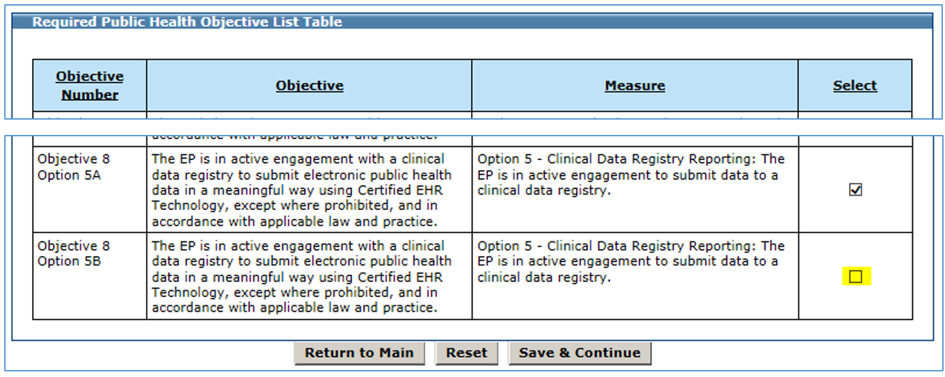
EPs who
took an Exclusion
to Option 5A should leave the Option 5B
Check Box
Blank

Screenshot from MAPIR: Objective 8 Option 5B – Clinical Data Registry Reporting

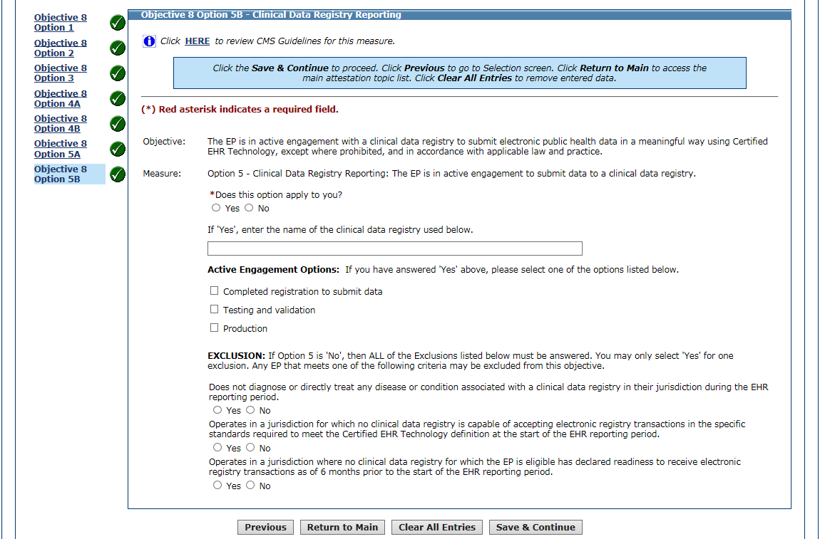

Eligible Professional  Name(s) | NPI | 2019 EHR/MU Reporting Period Dates | 5B: Clinical Data Registry  Active Engagement or Exclusion?
Use Page 7 to list more providers, if needed.

Attesting to Active Engagement for Option 5B

5B Active Engagement Option | 5B Description of Supporting Documentation
1. Completed registration to submit data | (Examples: Registration form, communications from registry acknowledging registration or confirming good standing for PY2019 EHR/MU Reporting Period.)
2. Testing and validation | (Examples: Dated letter, email or screenshot from the registry acknowledging testing. If Test Date is before 2019, include description of ongoing testing during 2019 EHR/MU Reporting Period.)
3. Production | (Examples: Dated record of the transmission/transaction log, letter or email from the registry acknowledging submission of production data during 2019 EHR/MU Reporting Period.)
Upload the documentation to the provider attestation(s) in MAPIR or email it to ahs.dvhaEHRIP@vermont.gov

Taking an Exclusion for Option 5B

5B Exclusion Option | 5B Description of Suggested Supporting Documentation
1. Does not diagnose or directly treat any disease or condition associated with a clinical data registry in their jurisdiction during the EHR reporting period. | Sample supporting documentation statements (use page 7 to submit):  “Other than the one attested to in Option 5A, I do not belong to any medical/specialty societies.”  Include signature and EHR/MU Reporting Period.
2. Operates in a jurisdiction for which no clinical data registry is capable of accepting electronic registry transactions in the specific standards required to meet the Certified EHR Technology definition at the start of the EHR reporting period. | Sample supporting documentation statements (use page 7 to submit):  “Other than the one attested to in Option 5A, the medical/specialty society or societies I belong to was/were not capable of accepting data at the start of my EHR reporting period.”  List medical and specialty society memberships as of the beginning of the EHR/MU Reporting Period, include signature and EHR/MU Reporting Period.
3. Operates in a jurisdiction where no clinical data registry for which the EP is eligible has declared readiness to receive electronic registry transactions as of six months prior to the start of the EHR reporting period. | Sample supporting documentation statements (use page 7 to submit):  “Other than the one attested to in Option 5A, the medical/specialty society or societies I belong to has/have not declared readiness to receive electronic registry transactions as of six months prior to the start of my EHR reporting period.”  List medical and specialty Society memberships as of the beginning of the EHR/MU Reporting Period, include signature and EHR/MU Reporting Period.
Upload the documentation to the provider attestation(s) in MAPIR or email it to ahs.dvhaEHRIP@vermont.gov

Use the space below to list additional providers and/or to submit provider exclusion statements and signatures.

