Public Health Registry Reporting for Eligible Professionals
Vermont Providers

Public Health Objective Documentation Aid
Program Year 2019, MU Stage 3: Objective 8 Option 4A and Option 4B

Option 4A

- The Vermont Department of Health has not declared readiness to accept Public Health Registry Reporting data from Eligible Professionals (EPs).

- Vermont EPs should not select Yes to Option 4A, Public Health Registry Reporting.

- All Vermont EPs must select No to Option 4A.

- All Vermont EPs may select Yes to this exclusion: “Operates in a jurisdiction where no public health registry for which the EP is eligible has declared readiness to receive electronic registry transactions
as of 6 months prior to the start of the EHR reporting period.

- No documentation is required to be submitted for the exclusion to Public Health Registry Reporting.

Please Note: The terms “EHR Reporting Period,” “MU Reporting Period”, and “Promoting Interoperability (PI) Reporting Period” all refer to the continuous 90-day period within the Program Year in which an Eligible Professional demonstrates meaningful use of certified EHR technology.

Screenshot from MAPIR: MU Stage 3 Objective 8 Option 4A – Public Health Registry Reporting

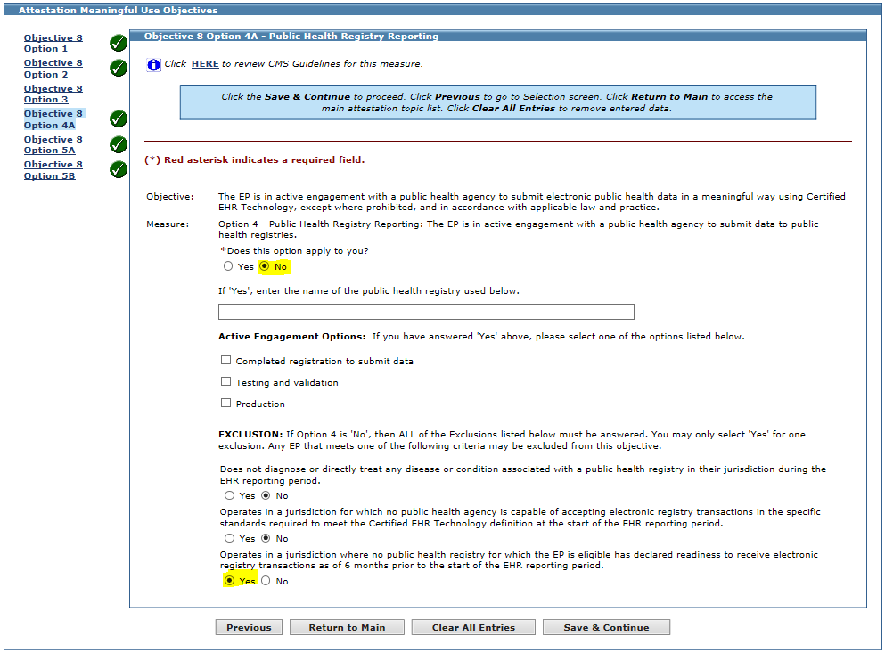

Option 4B

- MAPIR is configured to allow attestation for two Public Health Registries. Therefore, EPs have the ability to select Option 4A and Option 4B for this measure.

- Vermont EPs must exclude to Option 4A, and therefore are not required to select the checkbox or answer Option 4B.

- Per the screenshot below, Vermont EPs should leave the checkbox blank for Objective 8 Option 4B on the Required Public Health Objective List Table.

Screenshot from MAPIR: MU Stage 3 Required Public Health Objective List Table

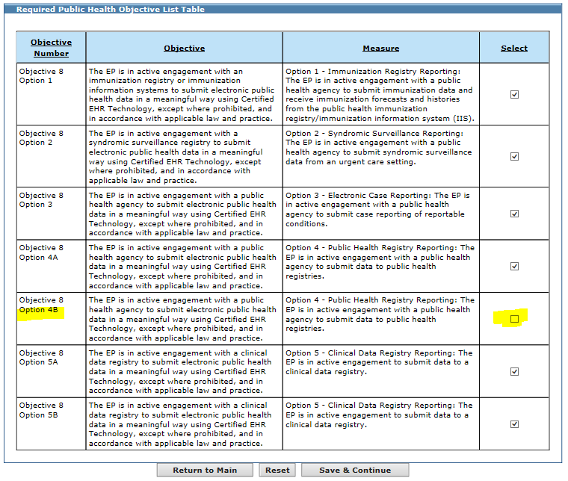
Leave
Option 4B
Check Box
Blank

