Public Health Registry Reporting for Eligible Professionals
New Hampshire Providers

Public Health Objective Documentation Aid
Program Year 2019, MU Stage 3: Objective 8 Option 4A and Option 4B

Objective 8 Option 4A

- The New Hampshire Department of Health and Human Services has declared readiness to accept Stage 3 Public Health Registry data in PY2019 for Cancer Case Reporting.

- A New Hampshire EP claiming an exclusion to Option 4A will need to submit documentation stating that reporting to the NH State Cancer Registry is not relevant to their scope of practice.

- This form may be used for multiple attesting NH EPs, if the supporting documentation applies to more than one provider at a practice location.

Please Note: The terms “EHR Reporting Period,” “MU Reporting Period”, and “Promoting Interoperability (PI) Reporting Period” all refer to the continuous 90-day period within the Program Year in which an Eligible Professional demonstrates Meaningful Use of certified EHR technology.

Screenshot from MAPIR: Objective 8 Option 4A – Public Health Registry Reporting

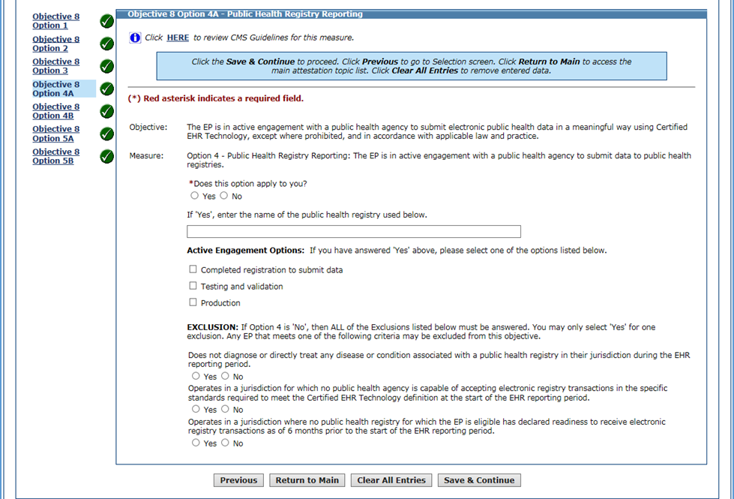

Instructions:
- List the NH provider names, NPIs and the 2019 EHR/MU Reporting Periods below.
- Indicate whether or not the NH providers:
  - Are in Active Engagement with the New Hampshire Cancer Case Reporting Registry, or
  - Qualified for an Exclusion.
- Describe the Active Engagement supporting documentation on Page 3.
- Please ensure the documentation supports the timeframes described in the Active Engagement definitions, available in the Specification Sheet.
- Utilize Page 5 for supporting documentation statements from NH providers taking an exclusion. All exclusions require a provider’s signature.
NH Eligible Professional  Name(s) | NPI | 2019 EHR/MU Reporting Period Dates | NH Cancer Case Registry  Active Engagement or Exclusion?

Use Page 5 to list more providers, if needed.

Attesting to Active Engagement for Option 4A

For New Hampshire Eligible Professionals who are in Active Engagement with the NH State Cancer Registry, describe the documentation and upload it to the MAPIR attestation or email it to:
ahs.dvhaEHRIP@vermont.gov.

Active Engagement Option | Description of Supporting Documentation
1. Completed registration to submit data | (Examples: Registration form, communications from NH State Cancer Registry acknowledging registration or confirming good standing for PY2019 EHR/MU Reporting Period.)
2. Testing and validation | (Examples: Dated letter, email or screenshot from the NH State Cancer Registry acknowledging testing. If Test Date is before 2019, include description of ongoing testing during 2019 EHR/MU Reporting Period.)
3. Production | (Examples: Dated record of the transmission/transaction log, letter or email from the NH State Cancer Registry acknowledging submission of production data during 2019 EHR/MU Reporting Period.)
Upload the documentation to the provider attestation(s) in MAPIR or email it to ahs.dvhaEHRIP@vermont.gov

Taking an Exclusion for Option 4A

For New Hampshire Eligible Professionals excluding from reporting to the NH State Cancer Registry, describe the documentation, ensure the EP’s signature EHR/MU Reporting Period is noted, and upload it to the MAPIR attestation or email it to: ahs.dvhaEHRIP@vermont.gov.

Exclusion Option | Description of Suggested Supporting Documentation
1. Does not diagnose or treat any disease or condition associated with a public health registry in their jurisdiction during the EHR reporting period. | Sample supporting documentation statements (use page 5 to submit):  “The New Hampshire Department of Health and Human Services Cancer Registry is not relevant to my scope of practice because __________ (please provide brief explanation).  Include signature and EHR/MU Reporting Period.
2. Operates in a jurisdiction for which no public health agency is capable of accepting electronic registry transactions in the specific standards required to meet the CEHRT definition at the start of the EHR reporting period. | This exclusion is not available for NH providers.
3. Operates in a jurisdiction where no public health registry for which the EP is eligible has declared readiness to receive electronic registry transactions as of 6 months prior to the start of the EHR reporting period. | This exclusion is not available for NH providers.
Upload the documentation to the provider attestation(s) in MAPIR or email it to ahs.dvhaEHRIP@vermont.gov

Objective 8 Option 4B

- MAPIR is configured to allow attestation for two Public Health Registries. Therefore, EPs have the ability to select Option 4A and Option 4B for this measure.

- New Hampshire has only one Public Health Registry. NH EPs who excluded to Option 4A because the NH Cancer Registry is not relevant to their scope of practice are not required to select the checkbox or answer Option 4B.

- Per the screenshot below, New Hampshire EPs excluding to Option 4A should leave the checkbox blank for Objective 8 Option 4B on the Required Public Health Objective List Table.

Screenshot from MAPIR: MU Stage 3 Required Public Health Objective List Table

Leave
Option 4B
Check Box
Blank
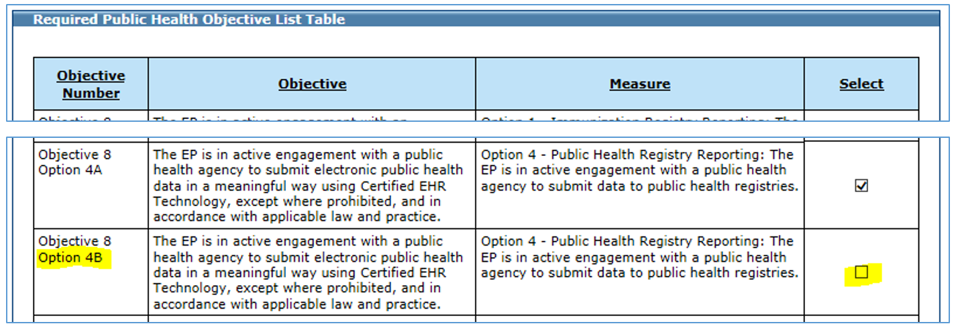
NH EPs who
took an Exclusion
to Option 4A should leave the Option 4B
Check Box
Blank

- Because New Hampshire has declared readiness to accept data for only one registry, NH EPs who attested to Active Engagement for Option 4A for the New Hampshire Cancer Registry will select the checkbox for Option 4B and take an exclusion.

- New Hampshire EPs may select Yes to this exclusion: “Operates in a jurisdiction where no public health registry for which the EP is eligible has declared readiness to receive electronic registry transactions as of 6 months prior to the start of the EHR reporting period.” No further documentation is required.

Screenshot from MAPIR: Objective 8 Option 4B – Public Health Registry Reporting

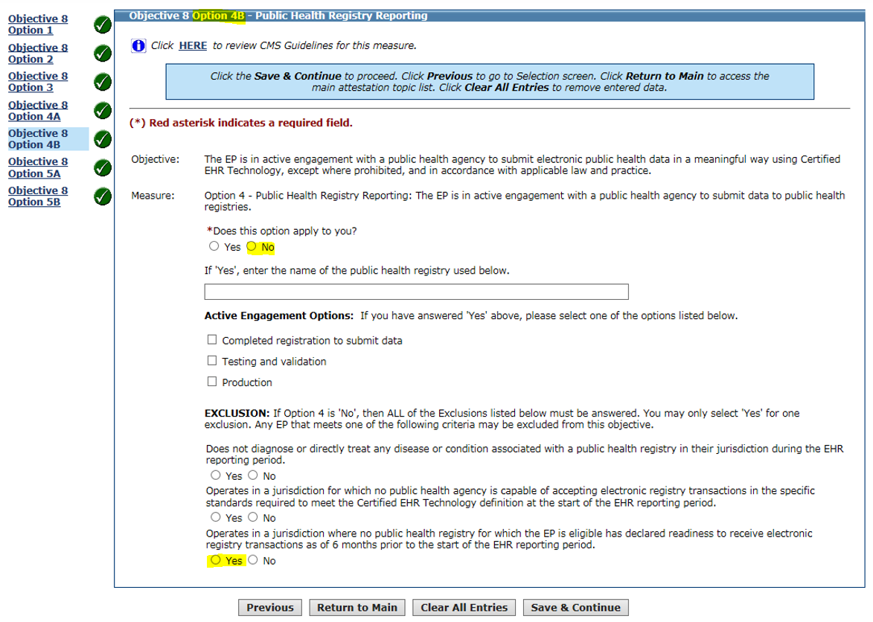

Use the space below to list additional providers and/or to submit provider exclusion statements and signatures.

