Immunization Registry Reporting for Eligible Professionals

Public Health Objective Documentation Aid
Program Year 2018, MU Stage 2: Objective 10 Option 1

- Documentation to support a provider’s attestation regarding Immunization Registry reporting is required at the time of application submission.
- This form may be used for multiple attesting Eligible Professionals (EPs), if the supporting documenation applies to more than one provider at a practice location.

Please Note: The terms “EHR Reporting Period,” “MU Reporting Period”, and “Promoting Interoperability Reporting Period” all refer to the continuous 90-day period within the Program Year in which an Eligible Professional demonstrates meaningful use of certified EHR technology.

Instructions:
- List provider names, NPIs and the 2018 EHR/MU Reporting Periods on Page 2.
- Indicate on Page 2 whether or not the providers:
  - Met the measure via Active Engagement with the Immunization Registry,
or
  - Qualified for an Exclusion.
- Describe the supporting documentation on Page 2.
- Please ensure the documentation supports the timeframes described in the Active Engagement definitions, available at our website and in the Specification Sheet.
- Include provider signature(s) on Page 3 if an exclusion is claimed for Immunization Registry reporting.
Screenshot from MAPIR: Objective 10 Option 1 – Immunization Registry Reporting
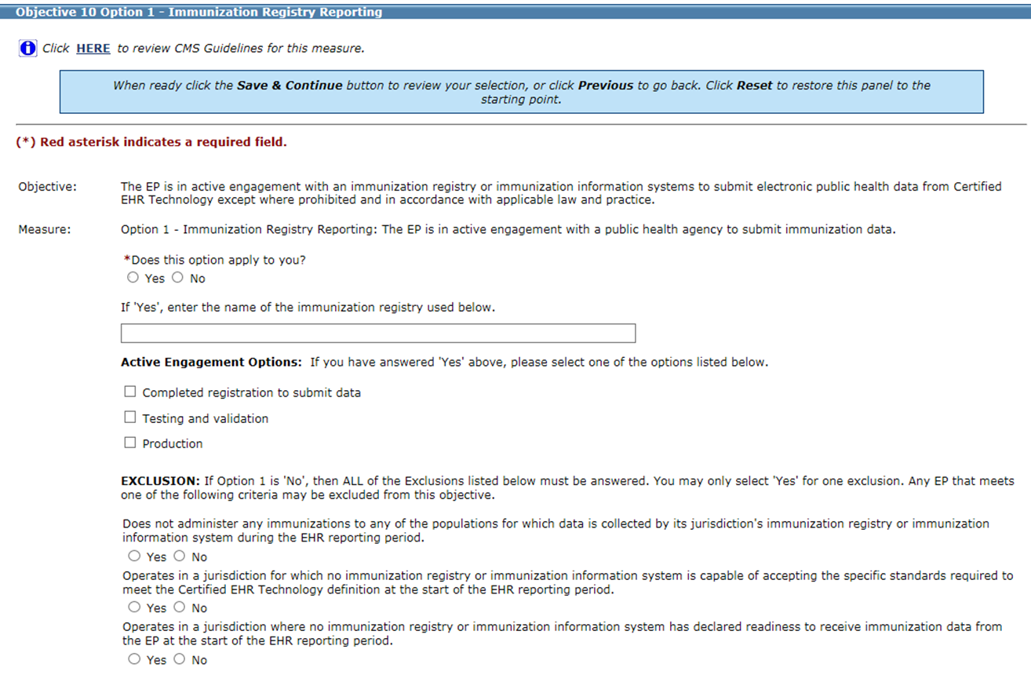

Eligible Professional  Name(s) | NPI | 2018 EHR/MU Reporting Period  Dates | Immunization Registry  Active Engagement or Exclusion?
(Use Page 3 to list more providers, if needed)
Active Engagement Option | Description of Supporting Documentation
1. Completed registration to submit data | (Examples: VT Department of Health (VDH) Registration form, communications from Immunization registry acknowledging registration and/or good standing for PY2018 EHR/MU Reporting Period.)
2. Testing and validation | (Examples: Dated letter, email, screenshot or VITL ticket from the registry acknowledging testing. If Test Date is before 2018, include description of ongoing testing during 2018 EHR/MU Reporting Period.)
3. Production | (Examples: Email from VDH’s Immunization Registry of your monthly HL7 report with dates that fall within your EHR/MU Reporting Period, or a letter from the registry acknowledging submission of production data during your 2018 EHR/MU Reporting period.)
Upload the documentation to the provider attestation(s) in MAPIR or email it to ahs.dvhaEHRIP@vermont.gov

Exclusion Option | Description of Supporting Documentation
1. Does not administer any immunizations to any of the populations for which data is collected by its jurisdiction’s immunization registry during the EHR reporting period. | (Example: Signed statement by EP confirming and explaining why no immunizations performed. (Use the box on Page 3 for statement and signature), or an EHR system report showing any immunizations performed but no data collected.)
2. Operates in a jurisdiction for which no immunization registry is capable of accepting the specific standards required to meet the CEHRT definition at the start of the EHR reporting period. | Not an available exclusion for Vermont EPs, as the Vermont Department of Health declared readiness as of February 2013.  New Hampshire EPs may take this exclusion, as the NH Department of Health and Human Services has not yet declared readiness. No other documentation is required from NH EPs.
3. Operates in a jurisdiction where no immunization registry has declared readiness to receive immunization data from the EP at the start of the EHR reporting period. | Not an available exclusion for Vermont EPs, as the Vermont Department of Health declared readiness to accept HL7 2.5.1 as of February 2013.  New Hampshire EPs may take this exclusion, as the NH Department of Health and Human Services has not yet declared readiness. No other documentation is required from NH EPs.
Upload the documentation to the provider attestation(s) in MAPIR or email it to ahs.dvhaEHRIP@vermont.gov

Use the space below to list additional providers and/or to submit provider exclusion statements and signatures.
Sample provider statement for supporting Exclusion Option 1 (please customize to accurately describe provider’s reason for exclusion):
“I do not administer immunizations in the scope of my practice.”
(Sign and date, ensure EHR/MU Reporting Period is included or listed on Page 2.)

