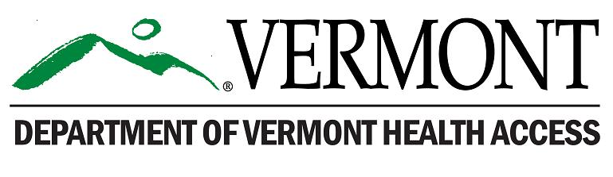
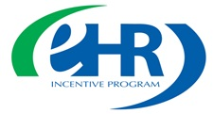
VT Medicaid Promoting Interoperability Program (PIP)/EHR Incentive Program Return Payment Form

Please use this form if you are returning a VT Medicaid PIP/EHR Incentive payment.
(1) Please return this form with your payment.
(2) Send an email to: ahs.dvhaehrip@vermont.gov, notifying them that you are returning payment and include your name and NPI number.
Name: Click here to enter text.
Business Address/City/State/ZIP: Click here to enter text.
Business Phone: Click here to enter text.
Alternate Phone: Click here to enter text.
Email: Click here to enter text.
Individual NPI: Click here to enter text.
CCN if a hospital: Click here to enter text.
Payee NPI: Click here to enter text.
Choose one: ☐ EP | ☐ Eligible Hospital
☐ I have received an Audit Results Notification letter and understand that as a consequence of being ineligible for the incentive payment I must return the funds and will lose the program year that I am returning payment for in the PIP/EHR incentive program.

Signature: Date:

If you were paid by EFT or cashed your original check, you should: Return your payment, please issue a check payable to DXC Technology.
Mail the check and this form to:
DXC Technology
Attention: Financial Department
PO Box 1645
Williston, VT 05495-1645

