Health Information Exchange

42 CFR Part 2 Data Governance Documentation

Version 1.1

Revision History

Date | Version | Description | Author(s)
6/26/2023 | 1.0 | Initial Draft | Kristin McClure  Mahesh ThopaSridharan
6/27/2023 | 1.1 | Feedback (comments) from Part 2 DG Group added | Mahesh ThopaSridharan

Table of Contents
Revision History 2
Purpose 4
Shared Values and Goals 4
Part 2 Data Governance Goals 4
Data Governance Structure 5
Part 2 Data Governance Subcommittee Decision Making 5
Part 2 Data Governance Subcommittee Membership 6
Securing Sensitive Data in the VHIE 6
Current State: 7
Interim State: 7
Future State: 9
Audit Reporting 9
Part 2 Consent, VHIE Consent (Opt-Out) and Revocation 9
Part 2 and VHIE Consent Process for New Patient 9
Part 2 and VHIE Consent Process for Existing Patient 10
VHIE Consent Revocation (opt-out) Process 10
Data set 10
Data Access and Data Use 10
Example Data Uses – AHS Reporting 11
Data Output 11
Record Retention and Destruction 11
Approvals 12

Purpose
This document is to serve as a reference for all involved parties, including but not limited to the ones listed below, to have a common understanding of the agreed upon approach to 42 CFR Part 2 (hereafter referred to as Part 2) Data Governance as it pertains to the Vermont Health Information Exchange (VHIE).
- Vermont Agency of Human Services (AHS)
- Vermont Information Technology Leaders (VITL)
- Vermont Care Partners (VCP)
- Designated Agencies (DA)
- Specialized Services Agencies (SSA)
- Vermont Department of Mental Health (DMH)
- Division of Substance Use Programs (DSU) / Vermont Department of Health (VDH)

Shared Values and Goals
- Ensuring access and minimal barriers to services for all Vermonters.
- Clear and shared understanding of governance process.
- We will establish data governance prior to any data being sent.
- Patients are at the center of their health data – all individuals can make informed decisions about the use of their health data.
- Policy makers / payers are able to assess value of programs and adapt to changing needs.
- AHS will not share data with law enforcement or anyone else.

Part 2 Data Governance Goals
- Short-term goals include conducting activities consistent with CFR Part 2 § 2.33:
  - Quality assessment, improvement initiatives, utilization review.
  - Business management activities related to compliance.
  - Other payment activities (e.g., determine need for adjustments to payment policies to enhance care).
- Long-term goals are currently centered on effective care coordination for individuals with substance use disorder (SUD)
  - Detailed long-term goals will be dependent upon ongoing rulemaking.
  - Moving towards care coordination goals will require the right individual-level data, at the right time, delivered to the right stakeholders that can impact the care and outcomes people with SUD.

Data Governance Structure
All domain teams, including Part 2 Data Governance Subcommittee, will share their decisions/recommendations with the HIE Data Council for its approval. Once the HIE Data Governance Council approves, it will be finalized and adopted as part of data governance.

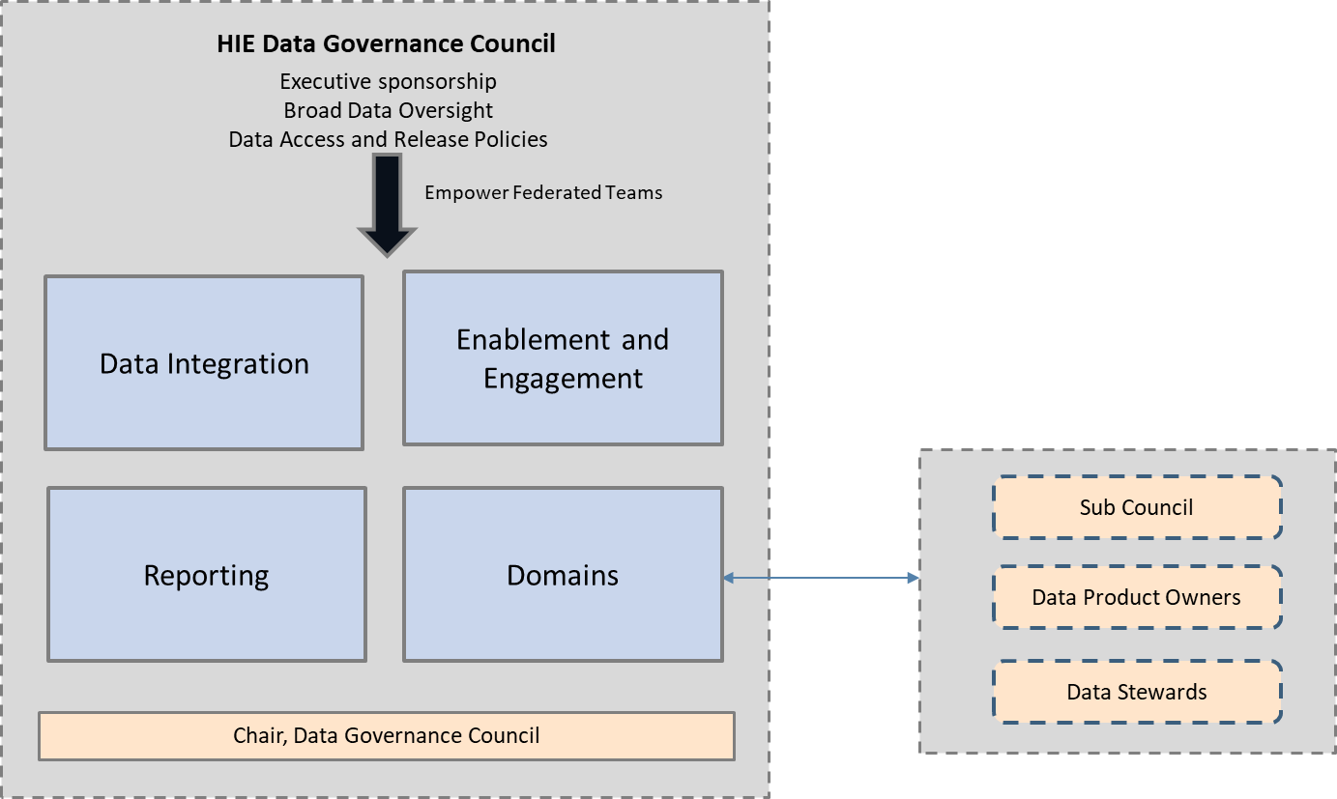

Part 2 Data Governance Subcommittee Decision Making

The Part 2 Data Governance Subcommittee is responsible for establishing data governance practices and processes for managing Part 2 data. The subcommittee is also responsible for providing their recommendations to the HIE Data Governance Council. The subcommittee is responsible for developing 42 CFR Part 2 data governance that aligns with Federal and State laws, rules, and regulations.
To ensure collaboration, it will be important that all stakeholders have equal input into key decision making. Discussions and any decisions must consider all perspectives so that final decisions are well-informed. As such, each member of the Part 2 Data Governance Subcommittee is a voting member.
Decisions will be made by a majority vote. For a vote, the total number of Part 2 Data Governance Subcommittee members required is half plus one. The subcommittee will determine if any additional parties are needed to be included to inform data governance decision making. Decisions will be logged by the scribe for that meeting. The subcommittee will produce a decision document that describes the decisions. These notes will be made public on the healthdata.vermont.gov website within 72 hours of the meeting.
Change management – any changes to the data governance of Part 2 Data will require it be brought forward to the Part 2 Data Governance subcommittee for a discussion and vote if necessary.

Part 2 Data Governance Subcommittee Membership

Name, Organization | Role
Kristin McClure, HIE/AHS | Health Data Officer
Tim Tremblay, HIE/AHS | Data Integration Lead
Stephen DeVoe, DMH/AHS | Director of Quality and Accountability
Anne VanDonsel, DSU/VDH/AHS | Director of Performance Management and Evaluation
Mahesh ThopaSridharan, HIE/AHS | IT Project Manager
Beth Anderson, VITL | President & CEO
Michele Boutin, CMC | Operations
Cheryl Cavanagh, HCRS | Compliance
Tim Gould, NKHS | IT Director
Nicholas Hunt, NKHS | Compliance
Dave Kronoff, HC | Compliance
Kim McClellan, NCSS | Operations
Laura Pearce, HC | Operations
Jit Singh, RMHS | IT Director
Eva Leonetti, UCS | HIM Lead & Privacy Officer
Ken Gingras, VCP | HIT Director
Simone Rueschemeyer, VCP | Executive Director​

Through this collaborative decision-making process among all involved stakeholders the subcommittee has reached consensus on the following key topics:

Securing Sensitive Data in the VHIE
VITL has proposed a current state in compliance with the current Part 2 provisions, an interim state, and a future state once the Proposed SAMHSA provisions are finalized.

Current State:
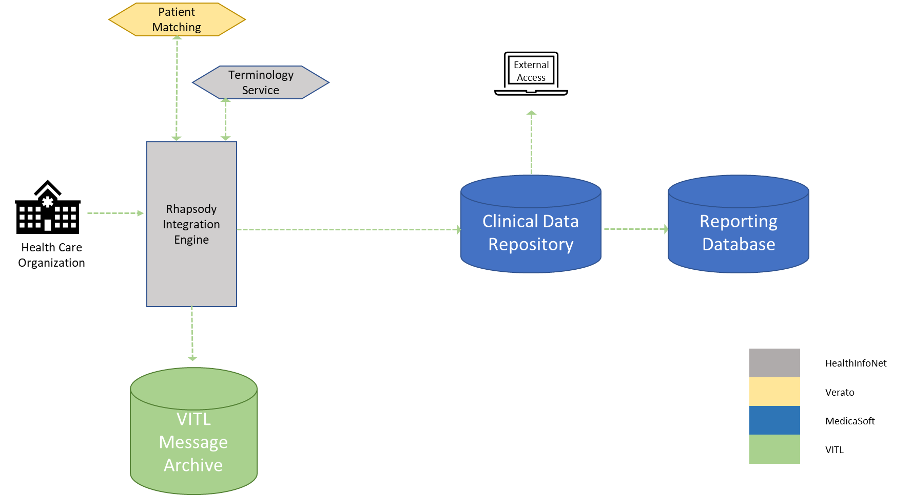

Interim State:

Part 2 Data: Initial Phase
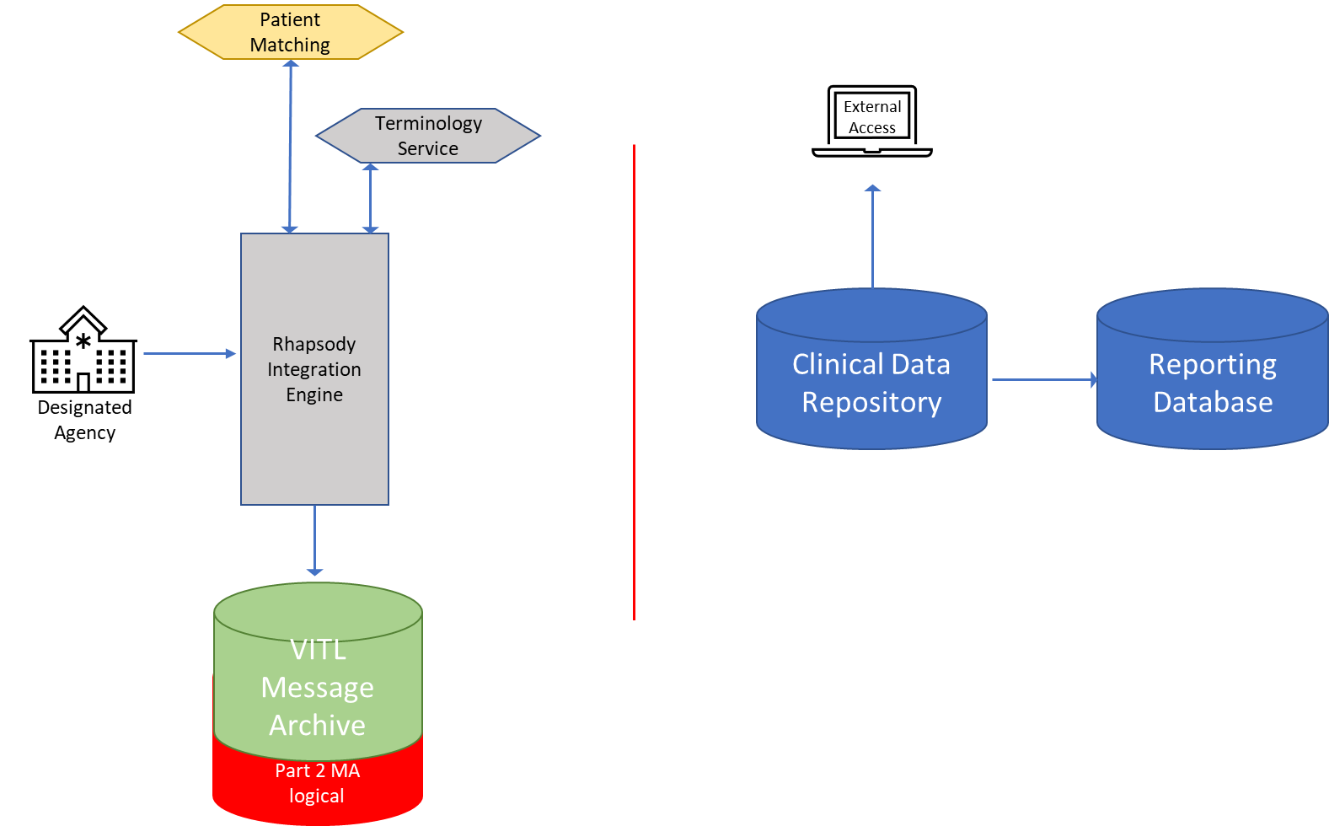

Part 2 Testing Security Model
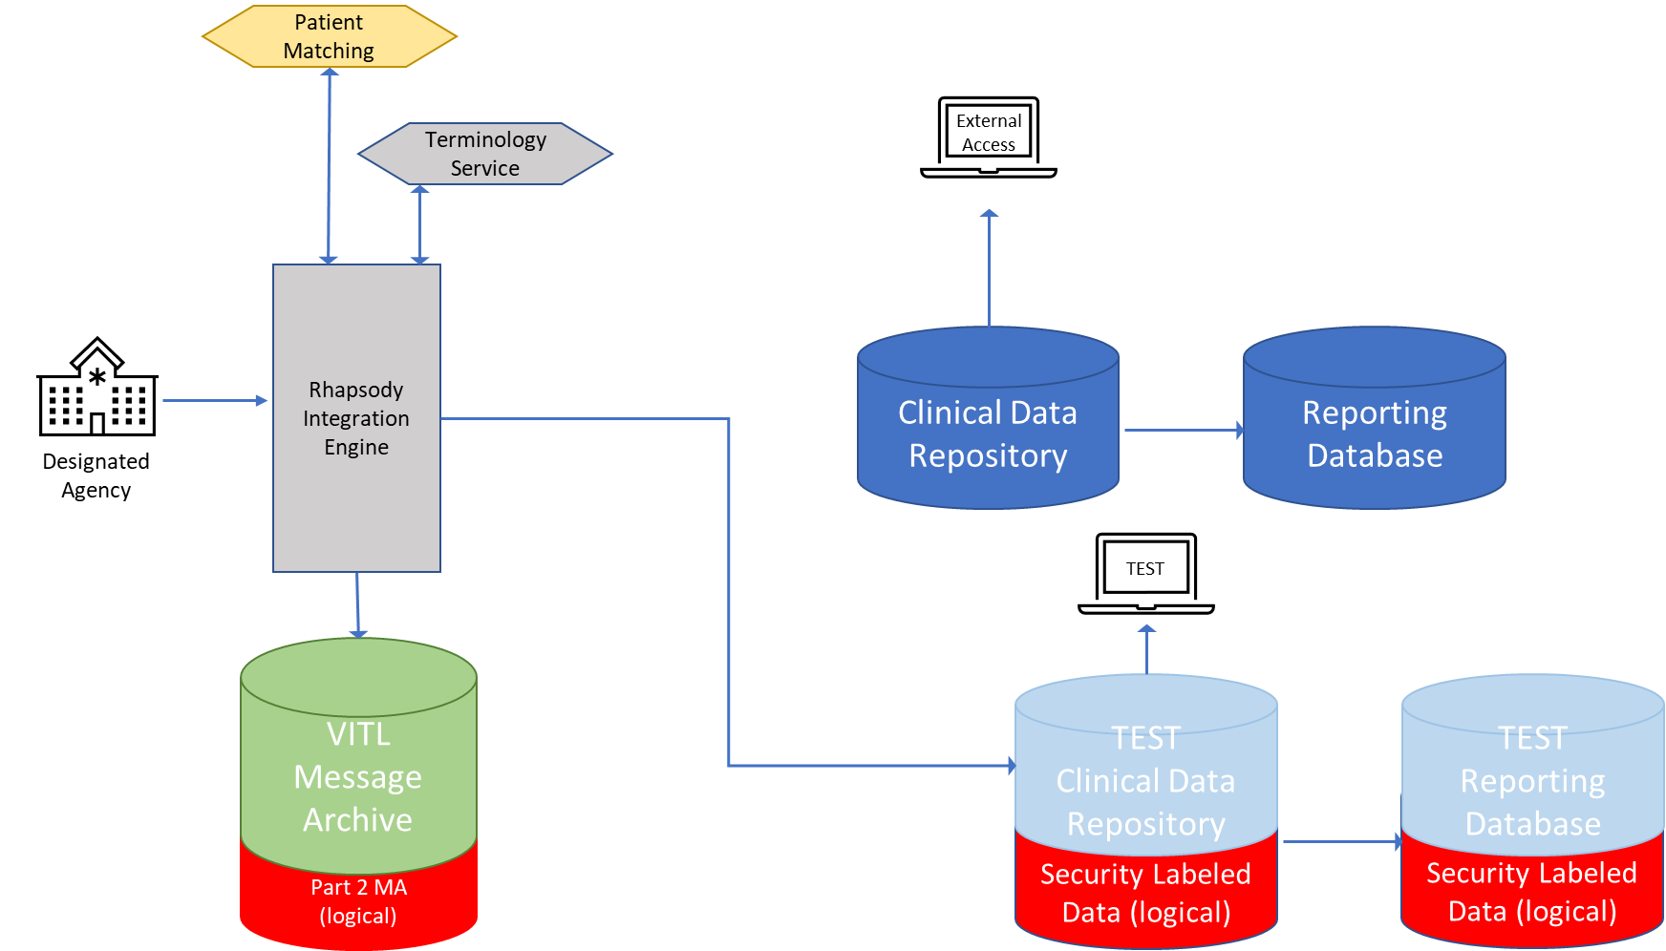

Part 2: Security Labels & State Reporting
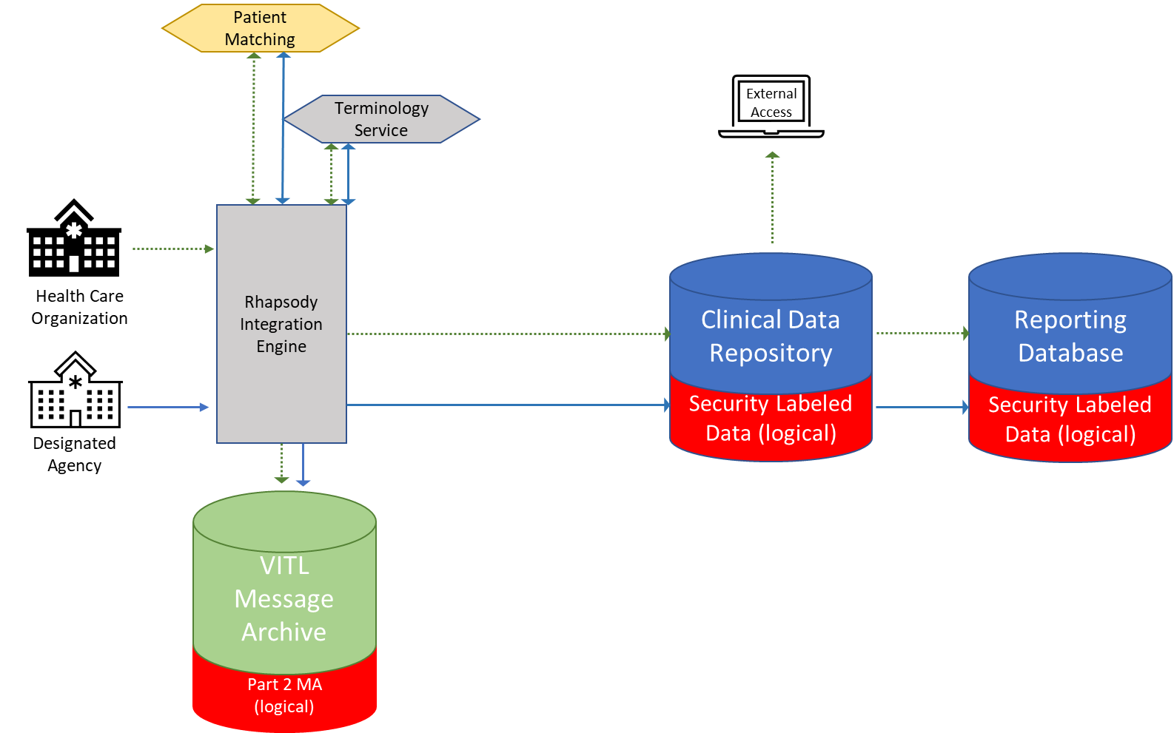

Future State:

Part 2: Updated Rule – External Sharing
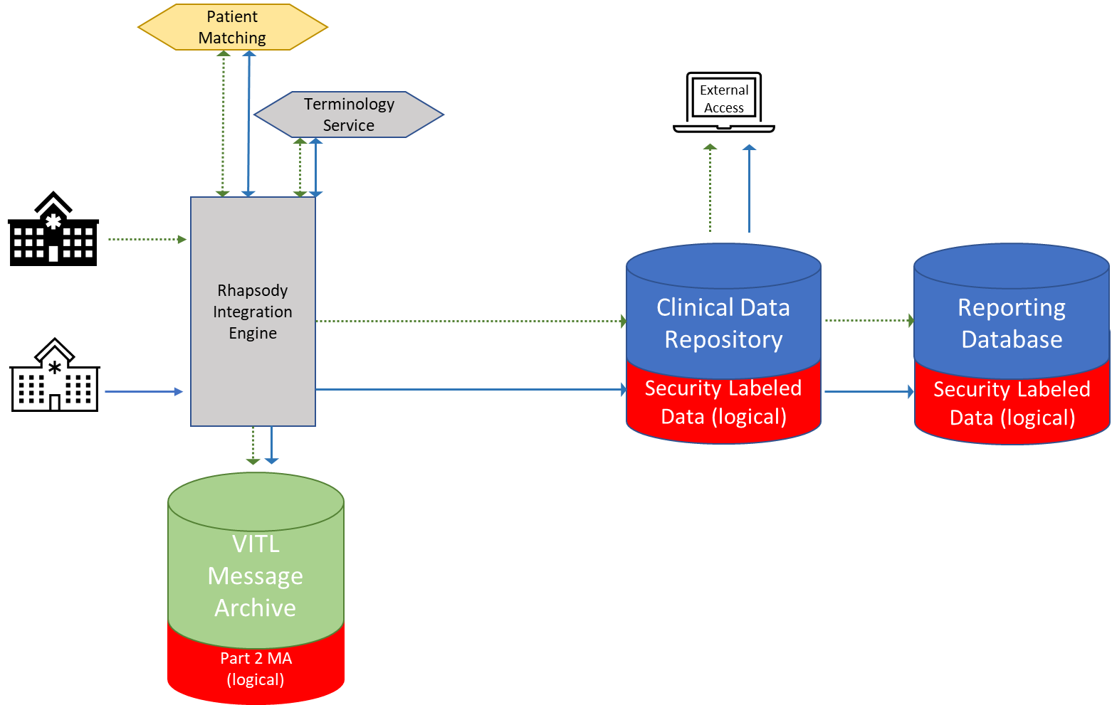

Audit Reporting
<Audit Reporting requirements yet to be defined>

Part 2 Consent, VHIE Consent (Opt-Out) and Revocation
The workflow updates required for capturing, updating, and sending Part 2 Consent from the DA EHR system to the VHIE and the subsequent steps at VITL to address the VHIE Opt-out with or without revocation has been discussed and examined by this subcommittee. AHS also agrees with the general direction pursued by the DAs to have the forms updated as necessary.

Part 2 and VHIE Consent Process for New Patient
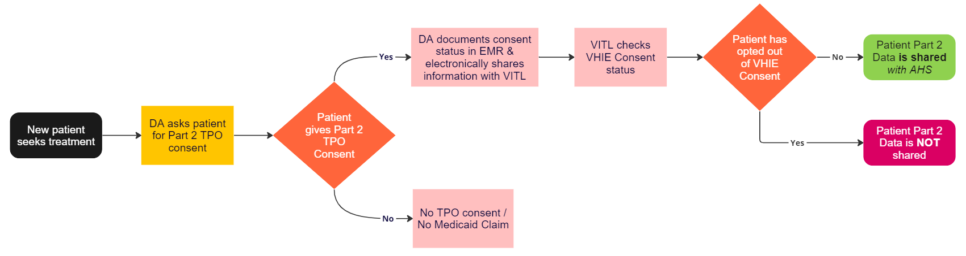

Part 2 and VHIE Consent Process for Existing Patient
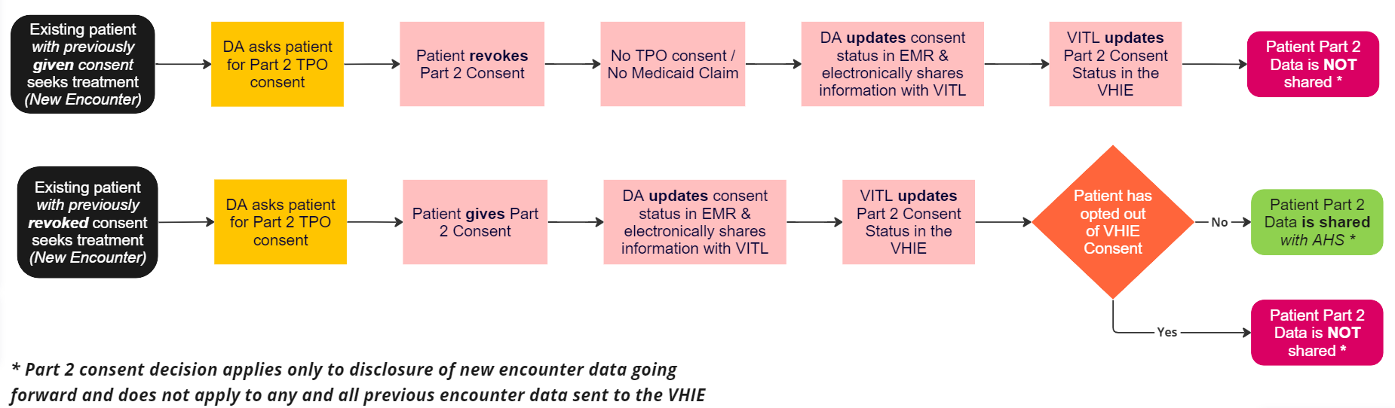

VHIE Consent Revocation (opt-out) Process
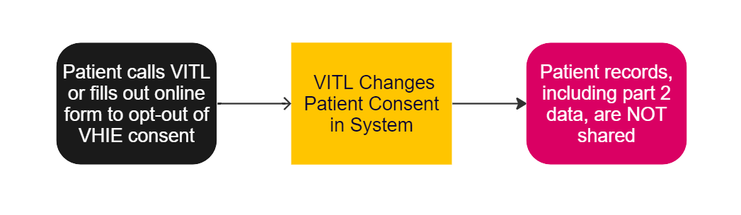

Data set
AHS had provided the DAs with the specific data elements AHS is seeking to access.
<Add>

Data Access and Data Use
With the current Part 2 Provisions in place –
- Data access in the VHIE will be limited to VITL only.
- AHS will be provided data extracts to satisfy the below mentioned data uses but will not have direct access to the date in the VHIE.
Once the proposed Part 2 provisions at SAMHSA become finalized, the subcommittee will reconvene to discuss and agree on future uses.

Example Data Uses – AHS Reporting
42 CFR Part 2 Provision | Use Case | Example (not an exhaustive list)
2.33 (b); #2, #10, #11, #12 | CMS Compliance Reporting | # of unique individuals receiving treatment for SUD; engagement rate; follow up with in 7 days and 30 days, Value-Based Payment measures
2.33 (b); #2, #10, #11 | State Operations Reporting | # / % screening for depression and follow up plan; screening for SDOH; follow up after hospitalization for SUD/Mental Health; follow up after ED visit for SUD; rate of growth of ED visits for SUD/Mental Health
2.33 (b); #1, #2, #4ii, #4iii, #5, #6, #7, #9, #10, #11, #12, #14, #15, #16, #17​, #18, #19 | - Departmental Clinical Operations  - Replacement/sunsetting of Monthly Service Report (MSR)​ processes * | - Performance Measures listed in Provider Agreement contracts  - Clinical Operations conducted by Departmental Care Management Teams (Children/Adults)
2.33 (b); #1, #2, #4ii, #4iii, #5, #6, #7, #9, #10, #11, #12, #14, #16, #17 | SAMHSA Grant Funding Requirement (SATIS – Substance Abuse Treatment Information System)* | SAMHSA - Admission, and Discharge data  DSU/AHS Reporting - Services data
2.33 (b); #2, #10, #11, #12 | CMS Compliance Reporting (Future Requirement)* | Quality measures which include (subset): Reassessment or care Plan Update after Patient Discharge; Admission to facility from the Community; Plan All-Cause Readmission

Data Output
Before data roll up occurs for any data extracts, AHS, VCP and VITL will make sure there is coordination and validation checks with the DA prior to publishing the content or sharing with other entities.

Record Retention and Destruction
Considering guidance from the following 42 CFR statutes, VITL will maintain patient records for 6 years (aligns to HIPAA).
- § 2.16 Security for records
- § 2.19 Disposition of records by discontinued programs

Approvals

Approver | Organization | eSignature/Date
Kristin McClure | Agency of Human Service – Central Office (AHS-CO)
Steve DeVoe | Department of Mental Health (DMH)/AHS
Anne VanDonsel | Division of Substance Use Programs (DSU)/VDH/AHS
Beth Anderson | Vermont Information Technology Leaders (VITL)
Simone Rueschemeyer | Vermont Care Partners (VCP)
Melanie Gidney | Clara Martin Center (CMC)
John Wurzbacher | Counseling Service of Addison County (CSAC)
Bob Stetzel | Howard Center (HC)
Warren Sergeant | Health Care & Rehabilitation Services (HCRS)
Asa Kuhn | Lamoille County Mental Health Services (LCMHS)
Kim McClellan | Northwestern Counseling & Support Services (NCSS)
Tim Gould | Northeast Kingdom Human Services (NKHS)
Jit Singh | Rutland Mental Health Services (RMHS)
Amy Fela | United Counseling Service of Bennington County (UCS)
Scott Adams | Washington County Mental Health Services (WCMHS)
Jennifer Epstein | Northeastern Family Institute (NFI)

