EXCERPT from
The National Institute of Standards and Technology HIPAA Security Rule Toolkit User Guide

How to Approach Questions
Most of the questions in the Toolkit can be answered by one of three choices:
• Yes
• No
• Not Applicable
Selecting either Yes or No is neither inherently correct nor incorrect. The answer truly depends
upon the size, implementation, and manner of justification provided by the respondent. Why is
this important? Consider the case studies below.

Case Study #1
In the following example, the question involves a number of elements to be addressed in an
organizations’ risk assessment policy.
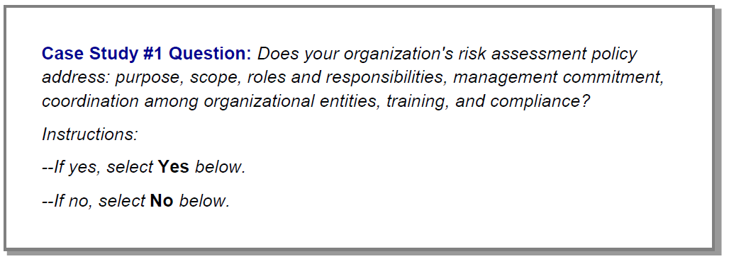
It may be that an organization has addressed some but not all of these elements in its risk
assessment policy documentation. If training and compliance were not addressed in the
documentation, should the user select the No option?
Not necessarily.
This will be a subjective evaluation after the pertinent documentation has been examined. The
user may feel that all elements of the question have been addressed and therefore feels
justified in selecting the Yes option. This can be true for any size organization. In either case, it
is suggested that the user make liberal use of the comments box. In this case, it is valid to
choose either Yes or No.

Case Study #2
In the following example, the user is asked to supply an answer and supporting information to
justify that answer.
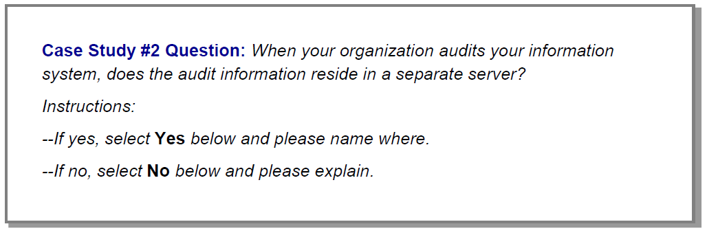

In both situations, the user is requested to document supplemental information in the comment
field. In many instances, the user is encouraged to make extensive use of the comment field to
provide additional information, reference internal documents, or add simple notes on a topic to
refer to later. Depending upon the manner in which an organization wishes to use the Toolkit,
the comments field can hold internal notes and detailed descriptions as to why a requirement
was or was not addressed.

