Specialized Registry Reporting for Eligible Professionals

Public Health Objective Documentation Aid
Program Year 2018, MU Stage 2: Objective 10 Option 3

- Documentation to support a provider’s attestation regarding Specialized Registry reporting is required at the time of application submission.
- This form may be used for multiple attesting Eligible Professionals (EPs), if the supporting documenation applies to more than one provider at a practice location.

Please Note: The terms “EHR Reporting Period,” “MU Reporting Period”, and “Promoting Interoperability Reporting Period” all refer to the continuous 90-day period within the Program Year in which an Eligible Professional demonstrates meaningful use of certified EHR technology.

Instructions:
- List the provider names, NPIs and the 2018 EHR/MU Reporting Periods on Page 3.
- Indicate on Page 3 whether or not the providers:
  - Met the measure via Active Engagement with a Specialized Registry, OR
  - Qualified for an Exclusion.
- Describe the Active Engagement supporting documentation on Page 3.
- Please ensure the documentation supports the timeframes described in the Active Engagement definitions, available at our website and in the Specification Sheet.
- Utilize Page 5 for supporting documentation statements from providers taking an exclusion.

The Blueprint for Health Vermont Clinical Registry is a Specialized Registry

If a provider meets Meaningful Use criteria for Active Engagement with the Blueprint for Health’s Vermont Clinical Registry, they may attest to the appropriate Active Engagement status in their MAPIR application. No further documentation is required at the time of attestation. The Vermont Medicaid Promoting Interoperability/EHR Incentive Program Team will verify the engagement status using administrative reports from the Vermont Clinical Registry. If additional documentation is required, we will follow up during the application review process.

Taking an Exclusion to Specialized Registry Reporting

All providers must engage in additional due diligence, per CMS FAQ 13657 before claiming an exclusion:

What steps does an Eligible Professional (EP) have to take to determine if there is a Specialized Registry available for them, or if they should instead claim an exclusion? EPs are not required to make an exhaustive search of all potential registries. Instead, they must do a few steps to meet due diligence in determining if there is a registry available for them, or if they meet the exclusion criteria.
- An EP should check with their State to determine if there is an available Specialized Registry maintained by a public health agency. The Vermont Department of Health does not have a Specialized Registry. The New Hampshire Department of Health and Human Services Cancer Registry accepts electronic reporting of cancer case data.
- An EP should check with any specialty/medical society with which they are affiliated to determine if the society maintains a Specialized Registry and for which they have made a public declaration of readiness to receive data for meaningful use no later than the first day of the provider’s EHR/MU Reporting Period.
If the EP determines no registries are available, they may exclude from the measure, but they must supply documentation to support that the above steps were taken at the time of attestation.

Attesting to Specialized Registry Reporting in MAPIR

- An Eligible Professional may report to more than one Specialized Registry. Specialized Registries may be sponsored or maintained by Public Health Agencies or other organizations, such as EHR vendors, national specialty or medical societies, patient safety organizations, or quality improvement organizations (e.g. the Vermont Blueprint for Health).
- An EP can count Specialized Registry reporting more than once to meet the Public Health objective, and MAPIR has two screens for Specialized Registry reporting:
  - Objective 10 Option 3A, and
  - Objective 10 Option 3B.
- If an EP answers ‘No’ to Option 3A, no data entry will be allowed for Option 3B.
Screenshot from MAPIR: Objective 10 Option 3A – Specialized Registry Reporting
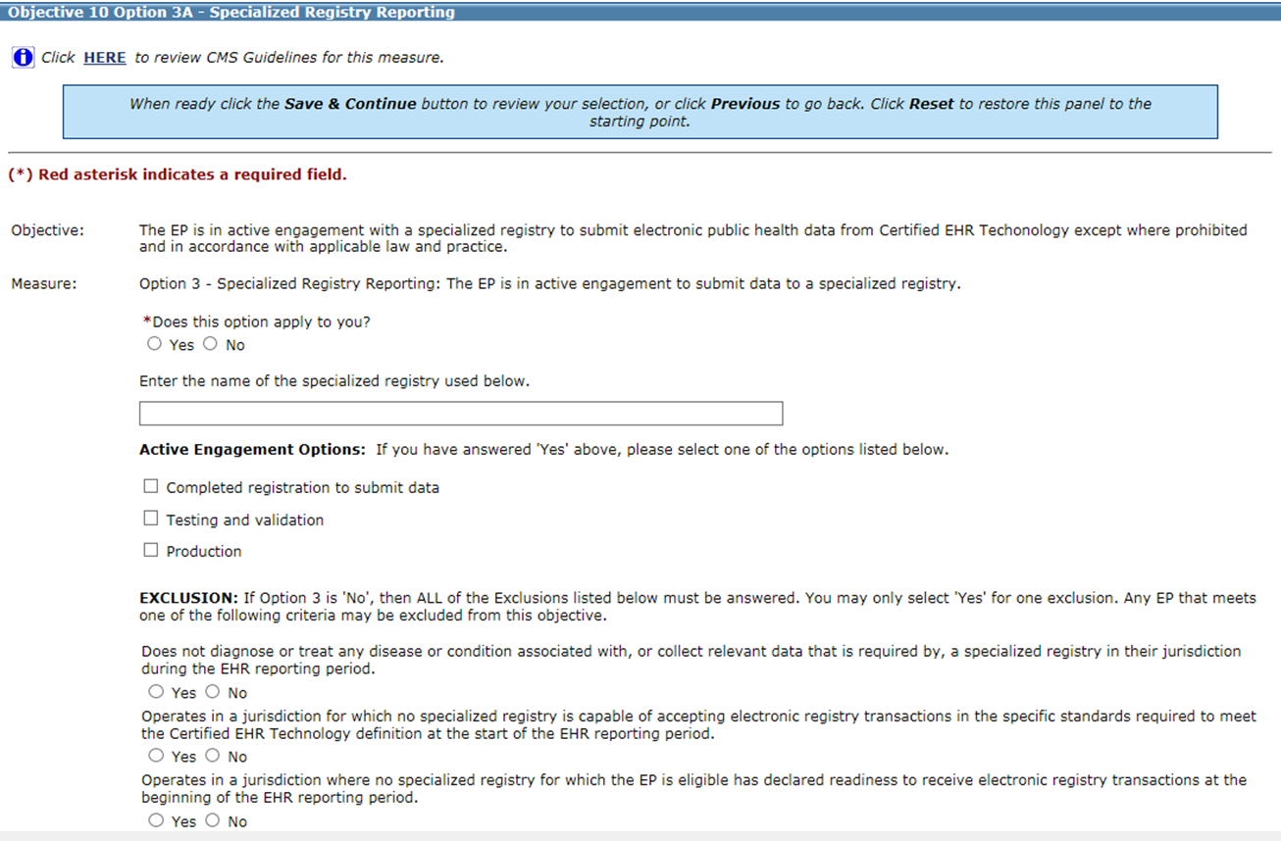

Screenshot from MAPIR: Objective 10 Option 3B – Specialized Registry Reporting
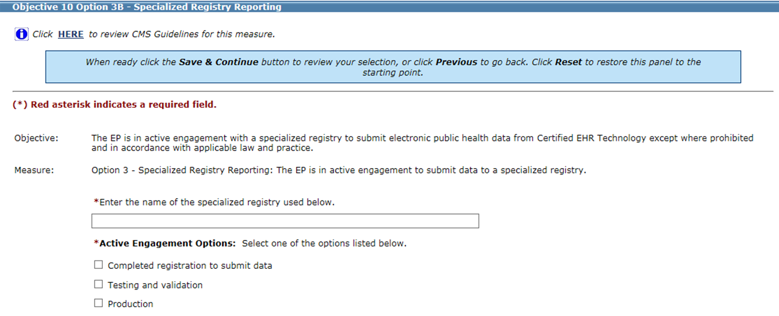

Eligible Professional  Name(s) | NPI | 2018 EHR/MU Reporting Period Dates | Specialized Registry  Active Engagement or Exclusion?

Use Page 5 to list more providers, if needed.

Active Engagement Option | Description of Supporting Documentation
1. Completed registration to submit data | (Examples: Registration form, communications from registry acknowledging registration or confirming good standing for PY2018 EHR/MU Reporting Period.)
2. Testing and validation | (Examples: Dated letter, email or screenshot from the registry acknowledging testing. If Test Date is before 2018, include description of ongoing testing during 2018 EHR/MU Reporting Period.)
3. Production | (Examples: Dated record of the transmission/transaction log, letter or email from the registry acknowledging submission of production data during 2018 EHR/MU Reporting Period.)
Upload the documentation to the provider attestation(s) in MAPIR or email it to ahs.dvhaEHRIP@vermont.gov
NOTE: Attesting to Active Engagement with the Blueprint for Health’s Vermont Clinical Registry
does NOT require documentation at the time of attestation.

Exclusion Option | Description of Suggested Supporting Documentation
1. Does not diagnose or treat any disease or condition associated with, or collect relevant data that is required by, a specialized registry in their jurisdiction during the EHR reporting period. | Sample supporting documentation statements (use page 5 to submit):  Vermont EP: “The Vermont Department of Health does not currently have a Specialized Registry AND I do not belong to any medical/specialty societies.”  Include signature and EHR/MU Reporting Period.  NH EP: “The New Hampshire Department of Health and Human Services Cancer Registry is not relevant to my scope of practice because __________ (please provide brief explanation) AND I do not belong to any specialty or medical societies.”  Include signature and EHR/MU Reporting Period.
2. Operates in a jurisdiction for which no specialized registry is capable of accepting electronic registry transactions in the specific standards required to meet the CEHRT definition at the start of the EHR reporting period. | Sample supporting documentation statements (use page 5 to submit):  VT EP: “The Vermont Department of Health does not currently have a Specialized Registry AND the medical/specialty society or societies I belong to was/were not capable of accepting data at the start of my EHR/MU reporting period.”  List medical and specialty Society memberships as of the beginning of the EHR/MU Reporting Period, include signature and EHR/MU Reporting Period.  NH EP: “The New Hampshire Department of Health and Human Services Cancer Registry is not relevant to my scope of practice because __________ (please provide brief explanation) AND the medical/specialty society or societies I belong to was/were not capable of accepting data at the start of my EHR/MU reporting period.”  List medical and specialty Society memberships as of the beginning of the EHR/MU Reporting Period, include signature and EHR/MU Reporting Period.
3. Operates in a jurisdiction where no specialized registry for which the EP is eligible has declared readiness to receive electronic registry transactions at the start of the EHR reporting period. | Sample supporting documentation statements (use page 5 to submit):  VT EP: “The Vermont Department of Health does not currently have a Specialized Registry AND the medical/specialty society or societies I belong to was/were not capable of accepting data at the start of my EHR/MU reporting period.”  List medical and specialty Society memberships as of the beginning of the EHR/MU Reporting Period, include signature and EHR/MU Reporting Period.  NH EP: “The New Hampshire Department of Health and Human Services Cancer Registry is not relevant to my scope of practice because __________ (please provide brief explanation) AND the medical/specialty society or societies I belong to was/were not capable of accepting data at the start of my EHR/MU reporting period.”  List medical and specialty Society memberships as of the beginning of the EHR/MU Reporting Period, include signature and EHR/MU Reporting Period.
Upload the documentation to the provider attestation(s) in MAPIR or email it to ahs.dvhaEHRIP@vermont.gov

Use the space below to list additional providers and/or to submit provider exclusion statements and signatures.

